**DAILY ONLINE ACTIVITIES SUMMARY**

|  |  |  |  |  |  |  |  |  |
| --- | --- | --- | --- | --- | --- | --- | --- | --- |
| **Date:** | **27/05/2020** | | | | | **Name:** | **Albin Francis** | |
| **Sem & Sec** | **8th sem,A** | | | | | **USN:** | **4AL16CS008** | |
| **Online Test Summary** | | | | | | | | |
| **Subject** | | **IOT** | | | | | | |
| **Max. Marks** | | **30** | | **Score** | | | **28** | |
| **Certification Course Summary** | | | | | | | | |
| **Course** | **Getting Started To Hadoop** | | | | | | | |
| **Certificate Provider** | | | **GreatLearning** | | **Duration** | | | **5.5hr** |
| **Coding Challenges** | | | | | | | | |
| **Problem Statement:  write a c program to sort an array of integers in ascending order and display the sorted array and number of passes performed for sorting.** | | | | | | | | |
| **Status: Solved** | | | | | | | | |
| **Uploaded the report in Github** | | | | | **Yes** | | | |
| **If yes Repository name** | | | | | **albinfrancis008** | | | |
| **Uploaded the report in slack** | | | | | **Yes** | | | |

Online Test Details: (Attach the snapshot and briefly write the report for the same)

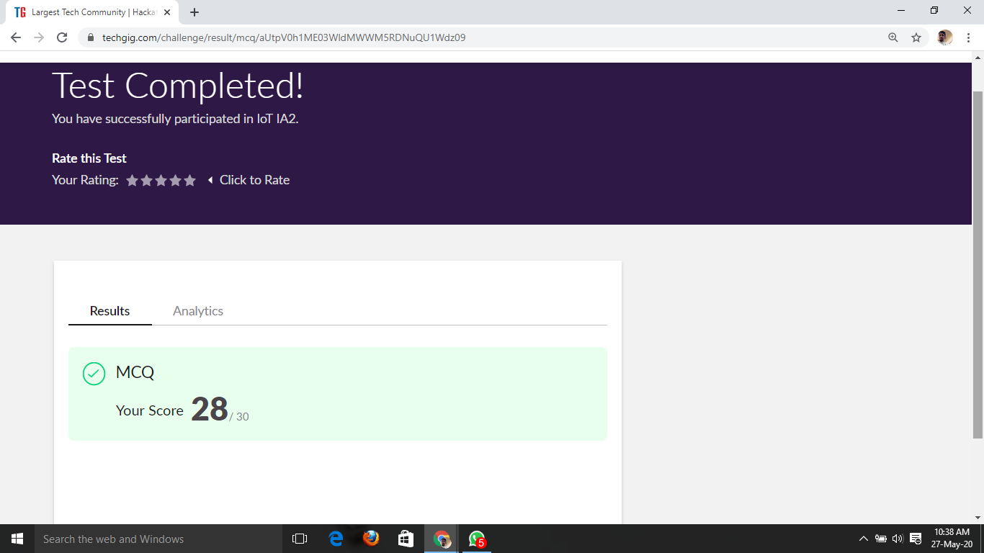

Certification Course Details: (Attach the snapshot and briefly write the report for the same)



HADOOP 1 VS HADOOP 2:-

* Difference between hadoop 1 and hadoop 2
* HDFS federation
* HDFS Federation is the way of creating and maintaining more than one NameNode independent of each other in a Hadoop cluster.
* HDFS consists of two parts, NameSpace and Block Storage.
* NameSpace resides in NameNode and is responsible for file handling operations.
* It also stores metadata about the file system.
* HDFS Namespace
* Read and Write Operations
* Name Node high availability
* Drawbacks with Name node Hadoop version 1
* Active And Standby Name node Hadoop version 2
* Understanding of Zookeeper Service
* And Deployment of Zookeeper Service

Coding Challenges Details: (Attach the snapshot and briefly write the report for the same)

**PROGRAM 1**

/* **write a c program to sort an array of integers in ascending order and display the sorted array and number of passes performed for sorting.**\*/

#include <stdio.h>

#define MAXSIZE 10

void main()

{

int array[MAXSIZE];

int i, j, num, temp,c1=0,c2=0;

printf("Enter the value of num \n");

scanf("%d", &num);

printf("Enter the elements one by one \n");

for (i = 0; i < num; i++)

{

scanf("%d", &array[i]);

}

printf("Input array is \n");

for (i = 0; i < num; i++)

{

printf("%d\t", array[i]);

}

for (i = 0; i < num; i++)

{

for (j = 0; j < (num - i - 1); j++)

{

if (array[j] > array[j + 1])

{

temp = array[j];

array[j] = array[j + 1];

array[j + 1] = temp;

c1++;

}

else

c2++;

}

}

printf("\nSorted array is...\n");

for (i = 0; i < num; i++)

{

printf("%d\t", array[i]);

}

printf("\nTotal Number of passes is : %d\n",c1+c2);

printf("No of passes the values were swaped : %d\n",c1);

printf("No of passes the values were already sorted : %d\n",c2);

}